**Experiment No: 04**

**Experiment Name:** VLAN configuration with layer 3 switch and router

**Objectives:**

A virtual LAN (VLAN) is a broadcast domain created by switches. VLANs are a convenient way to connect ports from different switches and different buildings onto the same network and broadcast domain, preventing the need for a complex system of subnets. In a sense VLAN configuration is our goal.

**Theory:**

This is done by configuration of the Switch or Router based on three methods, namely port based or MAC address based or IP address based configuration.

In port based VLANs, each port of the L2 switch is configured with a specific VLAN ID. Typically, multiple ports would have the same VLAN ID (all members of a specific VLAN). For example, ports 1 to 4 could be configured to belong to VLAN ID 1 and ports 5 to 8 could be configured to belong to VLAN ID 2.

In MAC based VLAN, the L2 Switch is configured with MAC address-VLAN ID pair combinations, so that the L2 switch decides the VLAN of a frame based on this mapping and the source MAC address of the incoming frame.

In IP address based classification, the L2 switch identifies the VLAN ID of an incoming frame using the IP address present in the L3 header. In this case, the L2 Switch is configured with IP Subnet ID – VLAN ID pair combinations.

**Equipment:**

Cisco Packet Tracer Software

1841 Router

2960-24TT Switch

PC-PT

**Procedure:**

1. Taking four PC-PT
2. Connecting them using 2960-24TT Switch
3. Connect the switch to 1841 router

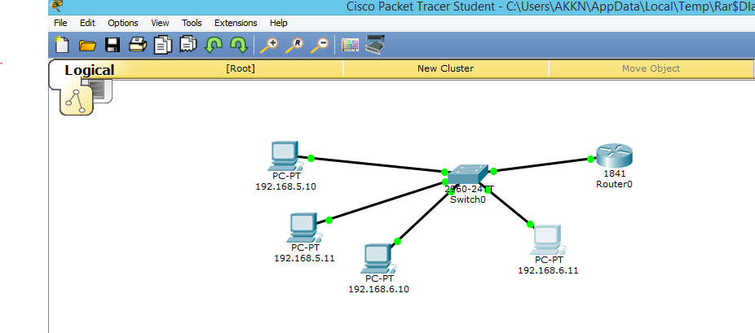

1. Configuring the router & switch respectively using following command

* Router configuration:

Continue with configuration dialog? [yes/no]: no

Press RETURN to get started!

Router>en

Router#conf t

Enter configuration commands, one per line. End with CNTL/Z.

Router(config)#int fa 0/0

Router(config-if)#no shut

Router(config-if)#int fa 0/0.1

Router(config-subif)#

%LINK-5-CHANGED: Interface FastEthernet0/0.1, changed state to up

Router(config-subif)#encapsulation dot1q 1

Router(config-subif)#ip add 192.168.5.1 255.255.255.0

Router(config-subif)#int fa 0/0.2

Router(config-subif)#

%LINK-5-CHANGED: Interface FastEthernet0/0.2, changed state to up

%LINEPROTO-5-UPDOWN: Line protocol on Interface FastEthernet0/0.2, changed state to up

Router(config-subif)#encapsulation dot1q 10

Router(config-subif)#ip add 192.168.5.1 255.255.255.0

% 192.168.5.0 overlaps with FastEthernet0/0.1

Router(config-subif)#int fa 0/0.3

%LINK-5-CHANGED: Interface FastEthernet0/0.3, changed state to up

%LINEPROTO-5-UPDOWN: Line protocol on Interface FastEthernet0/0.3, changed state to up

Router(config-subif)#encapsulation dot1q 20

Router(config-subif)#ip add 192.168.6.1 255.255.255.0

Router(config-subif)#end

Router#

%SYS-5-CONFIG_I: Configured from console by console

Router#exi

Router con0 is now available

Press RETURN to get started.

Router>sh vlan brief

Router con0 is now available

Press RETURN to get started.

* Switch configuration:

Switch>en

Switch#vlan database

% Warning: It is recommended to configure VLAN from config mode,

as VLAN database mode is being deprecated. Please consult user

documentation for configuring VTP/VLAN in config mode.

Switch(vlan)#vlan 10 name A

VLAN 10 added:

Name: A

Switch(vlan)#vlan 20 name B

VLAN 20 added:

Name: B

Switch(vlan)#exit

APPLY completed.

Exiting....

Switch#conf t

Enter configuration commands, one per line. End with CNTL/Z.

Switch(config)#int fa 0/2

Switch(config-if)#switchport mode access

Switch(config-if)#switchport access vlan 10

Switch(config-if)#int fa 0/3

Switch(config-if)#switchport mode access

Switch(config-if)#switchport access vlan 10

Switch(config-if)#int fa 0/4

Switch(config-if)#switchport mode access

Switch(config-if)#switchport access vlan 20

Switch(config-if)#int fa 0/5

Switch(config-if)#switchport mode access

Switch(config-if)#switchport access vlan 20

Switch(config-if)#end

Switch#

%SYS-5-CONFIG_I: Configured from console by console

Switch#conf t

Enter configuration commands, one per line. End with CNTL/Z.

Switch(config)#int fa 0/1

Switch(config-if)#switchport mode trunk

Switch(config-if)#end

Switch#

%SYS-5-CONFIG_I: Configured from console by console

Switch#

%LINK-5-CHANGED: Interface FastEthernet0/1, changed state to up

%LINEPROTO-5-UPDOWN: Line protocol on Interface FastEthernet0/1, changed state to up

Switch#exit

Switch con0 is now available

Press RETURN to get started.

Switch>sh vlan brief

VLAN Name Status Ports

---- -------------------------------- --------- -------------------------------

1 default active Fa0/6, Fa0/7, Fa0/8, Fa0/9

Fa0/10, Fa0/11, Fa0/12, Fa0/13

Fa0/14, Fa0/15, Fa0/16, Fa0/17

Fa0/18, Fa0/19, Fa0/20, Fa0/21

Fa0/22, Fa0/23, Fa0/24, Gig1/1

Gig1/2

10 A active Fa0/2, Fa0/3

20 B active Fa0/4, Fa0/5

1002 fddi-default active

1003 token-ring-default active

1004 fddinet-default active

1005 trnet-default active

Switch>

**Conclusion:**

VLANs are created mainly for administrative purposes to ensure that network traffic is seen only by members of a specific group, rather than by all members of the LAN.